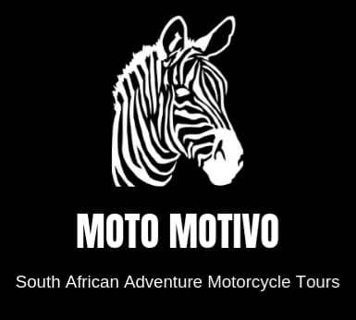

2023 Moto Motivo South African Adventure Motorcycle Tour.

Johann Keyser (919) 924-9891 johannkeyser@nc.rr.com

Day 1 Friday, March 3.

- Arrive at Cape Town International Airport, South Africa.
- I will collect you from the airport, some of us will arrive a few days earlier.
- Book in at D'Aria wine estate.
- We have three restaurants on the wine farm to choose from for our dinner.

Day 2 Saturday, March 4

- Breakfast at a neighboring wine farm. Beautiful views and great food!
- Collect bikes and the backup vehicle in Cape Town at the rental company.
- We will do a short ride (50 km) up the West Coast to get acquainted with the bikes, truck, fellow riders, and driving on the LHS of the road.
- We will have dinner at one of the three restaurants on the wine farm.

Day 3 Sunday, March 5

Cape Town - Cape Point – Stellenbosch 205km 3h50 (VERY RELAXED RIDE)

- Breakfast at a neighboring wine farm.
- Today we will do a very scenic ride following the coastline.
- Stop 1: Boulders to see Penguins. These penguins are so tame that they sleep in and around private home yards located just across the road from the beach. They also adapted to the warm water of the South African coast.
- Stop 2: Cape of the Good Hope. Situated in a Nature Reserve. Spectacular ocean views. Baboons, Ostriches, Antelope, and wildflowers.
- Stop 3: Hout Bay for a fish & chips lunch. Fishing harbor with an excellent seafood restaurant.
- Stop 4: Stellenbosch. ONE OF THE HIGH POINTS OF THE TRIP!! Book in at Spier Wine Farm. The farm was established in 1692 and is one of South Africa's most historic wine farms. Stellenbosch is called The City of Oaks and was founded in 1679 and is the wine-growing "capital" of South Africa. Also known for one of the best universities in Africa, the University of Stellenbosch. My wife graduated from this university. https:www.spier.co.za/about-us
- Please make sure that you get a good night's rest. The ride tomorrow is going to be a bit longer.
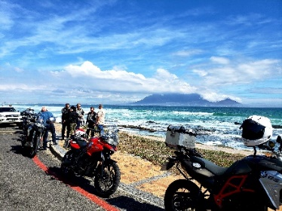
- We will enjoy dinner at one of the restaurants on the Wine Estate.
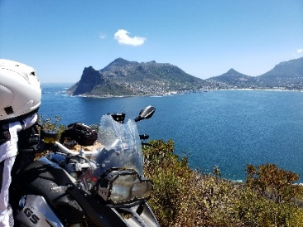

Day 4 Monday, March 6

Stellenbosch - Swellendam 364km 5h30 (LONGER RIDE with 47km DIRT)

- Breakfast will be enjoyed on the Spier Estate with breathtaking views of the Stellenbosch Mountains and is surrounded by vineyards.
- Wheels are rolling by 8 am.
- Great twisty coast-hugging roads.
- Stop 1: Hermanus. Stretch legs, have a drink break, and we might even see some whales. Hermanus has, since August 1992, the world's only Whale Crier who sounds his kelp horn to announce where whales are sighted.
- Stop 2: Gans Bay. Home of the famous shark alley and Great White shark cage diving. The main tourist attraction in Gans Bay since approximately 1995 has been cage diving with Great White sharks. It is said that after Kruger National Park, the Great White sharks attract some of the highest number of tourists to South Africa for any singular activity.
- Stop 3: Cape Agulhas. Southern most point of Africa. Great looking lighthouse for photo opportunities. You can stand with one foot in the Indian Ocean and the other in the Atlantic Ocean. 47km Dirt Road on this stretch. We will enjoy lunch at the Zuidste Kaap Restaurant (The southernmost restaurant in Africa.)
- Stop 4: Swellendam. Book in at Aan De Oever (next to the river) Guesthouse.
- Aan De Oever is a guesthouse in the Cape Dutch style, located in this well-known 3rd oldest town in South Africa. This will be an excellent experience for you; this place is great!
- Dinner at The Old Mill Restaurant. A fantastic menu that includes some game (Springbok, Kudu &
Ostrich).

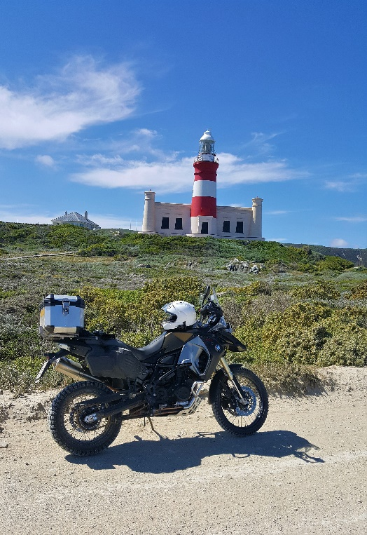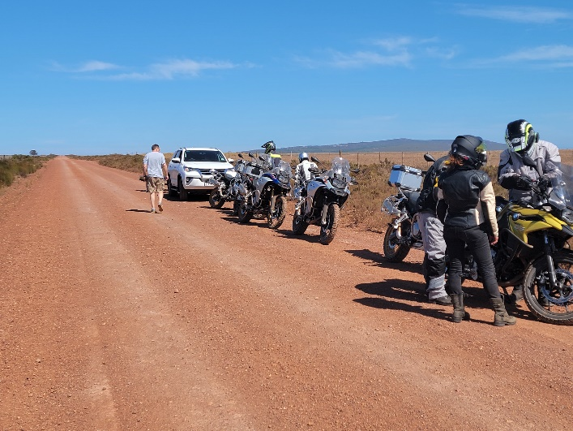

Day 5 &6 Tuesday/Wednesday, March 7 &8.

Swellendam – Knysna 271 KM (3h30)

- Great country-style farmers' breakfast at the guesthouse. (One of the best breakfast meals on tour)

Today's scenic ride will take us to The Knysna Elephant Park.

This facility in South Africa cares for orphaned African elephants. Over the last twenty years, the park has cared for and raised more than forty elephants.

Thursday we will visit the elephants where we can interact with them, great experience!!

Tuesday dinner will be at the Indlovu Café. The café is alongside a beautiful dam and offers a place to relax and reflect on your elephant experience. A wooden deck allows you to sit close to the water, sip freshly squeezed juice, and admire the birdlife that frequents the dam.

Wednesday breakfast -Indlovu Café.

Wednesday dinner - Indlovu Café.

Thursday breakfast - Indlovu Café.

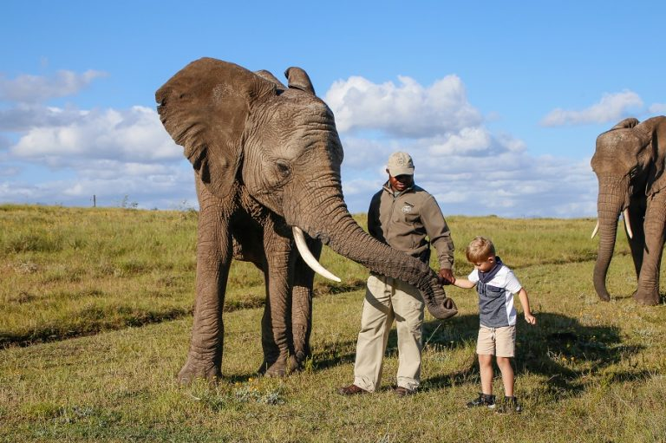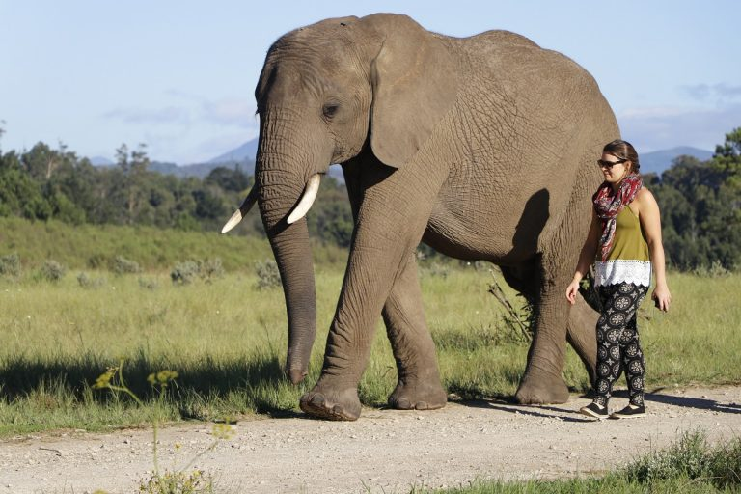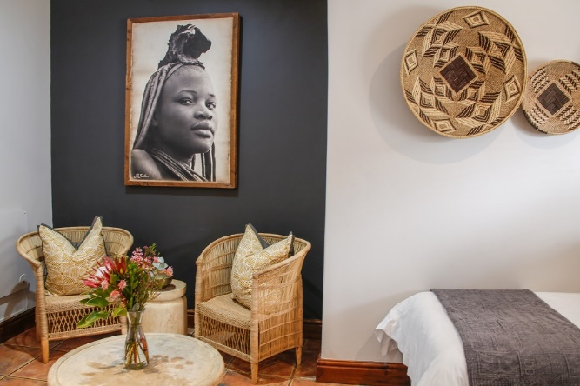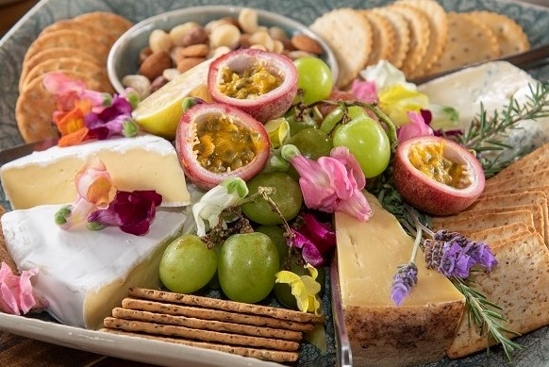

Day 7,8 & 9 Thurs/Fri/Sat March 9,10,11
Knysna – Swartberg Private Game Lodge 240 KM (3 hours)

Wheels rolling by 8 am

Today we will ride through the Langkloof (Long Valley), the fruit basket of SA, to Oudtshoorn.

Oudtshoorn is known as the ostrich capital of the world and is in the Klein Karoo (semi-desert)

Oudtshoorn is home to Ostrich Farms and the spectacular underground Cango Caves.

We will visit The Cango Wildlife Ranch, where you interact with a Cheetah!

The Swartberg Mountains are part of the Cape Floral UNESCO World Heritage Site.

From Oudtshoorn, we ride to the Swartberg (Black Mountain) Private Game Lodge.

Great dirt roads included.

I booked the Game Lodge for our group exclusively.

We are staying for three nights.

Game drives in an open game viewing vehicle (Land Rover)

We will also travel to and ride the Swartberg Pass (Please Google it!!) This pass is one of the best dirtroad mountain passes in the world.

The Swartberg Private Game Lodge is one of the best (if not the best) lodges I have ever visited; this place is FANTASTIC!! The lodge owner is one of my best friends from high school.

I arranged for a private chef and butler to take care of us and to make this the best experience on tour.

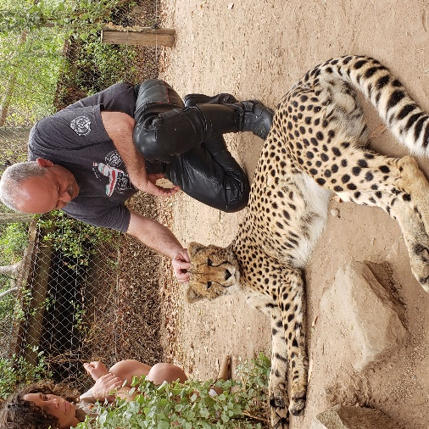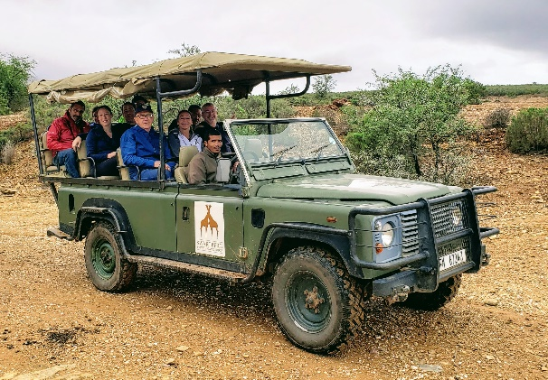
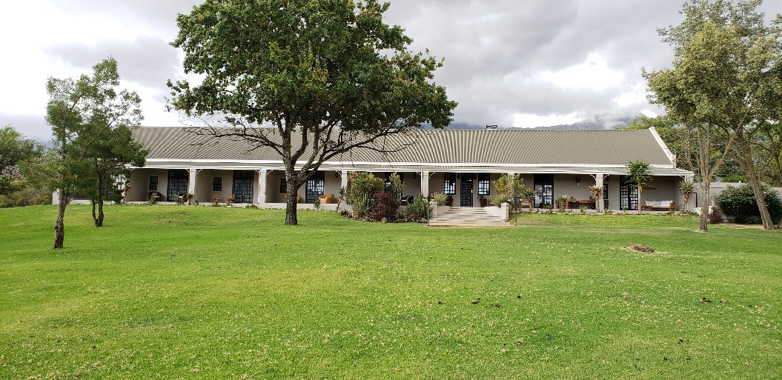
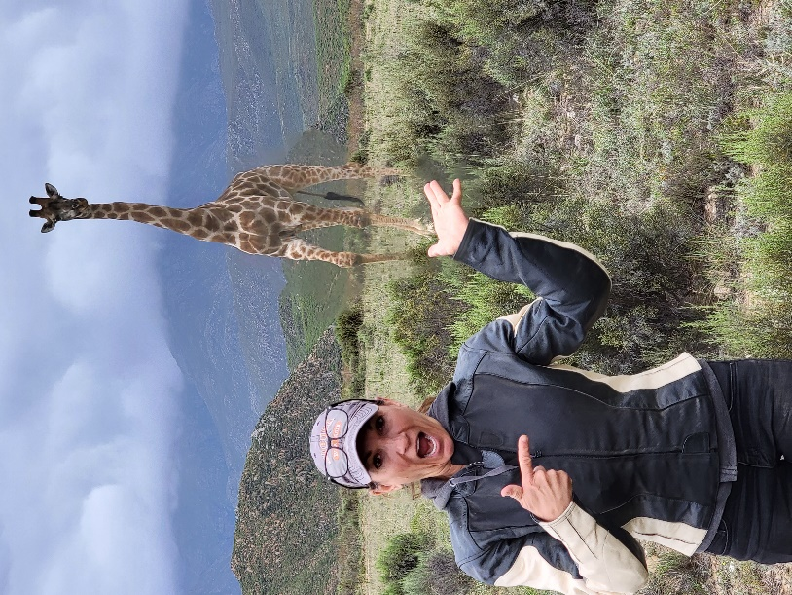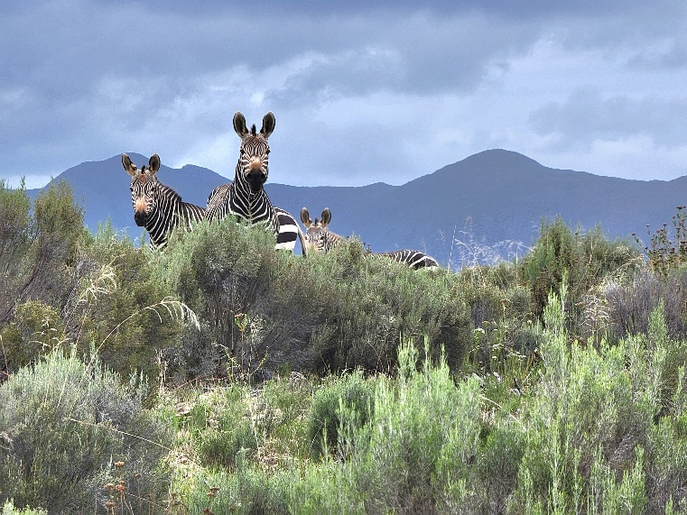

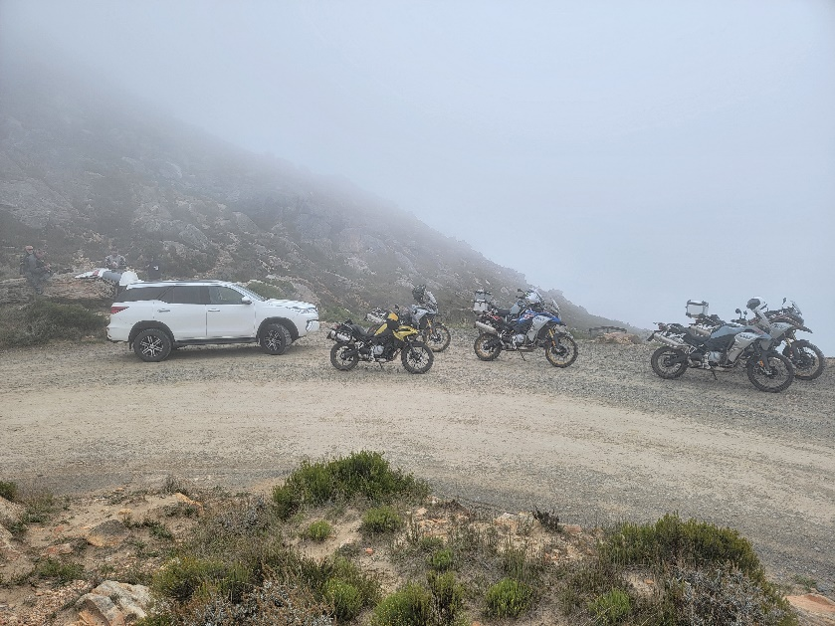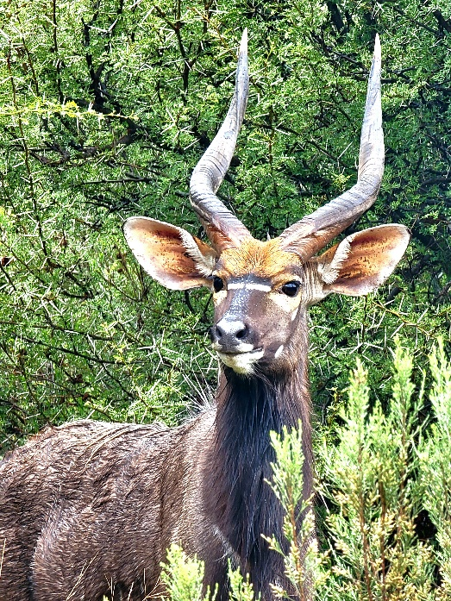

Day 10 & 11 Sun/Mon March 12 & 13.
Swartberg Private Game Lodge - Franschhoek 360 KM (4 h)
- Breakfast at the lodge
- Motorcycle stands up at 8 am.
- Lovely dirt roads through farms and mountains this morning to meet with Route 62. Google it!
- Today we leave the Klein Karoo behind and move back to the beautiful Winelands of the Western Cape.
- We will visit Ronnie's Sex Shop in Barrydale en route to the Cape Winelands. Despite the name, it is a famous dive bar with graffiti plastered walls on Route 62 and a fun stop for a cold drink and a stretch of the legs.
- Great roads and mountain passes today.
- We are staying at Mont d'Or in Franschhoek for two nights. (https://www.montdorfhk.co.za/)
- Franschhoek is Nestled between towering mountains in the beautiful Cape Winelands and lies in the magnificent Franschhoek Valley. Here breathtaking scenery, warm hospitality, world-class cuisine, and the finest wines create lasting memories. Franschhoek is the food and wine heartland of the country, where splendid wines are grown, and our top chefs create international cuisine.
- Franschhoek is a town in South Africa's Western Cape with centuries-old vineyards and Cape Dutch architecture. Trails wind through flowers and wildlife at Mont Rochelle Nature Reserve to views over Franschhoek Valley. The Huguenot Memorial Museum and neighboring monuments honor the area's French settlers, who arrived in the 17th and 18th centuries.
- We will take the wine tram to visit several Wine estates for wine tasting with paired foods.
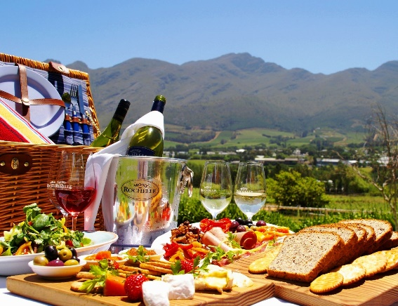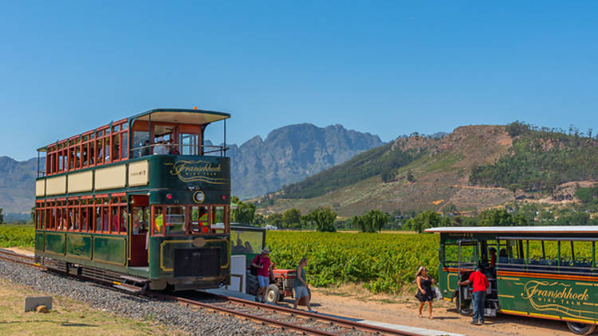
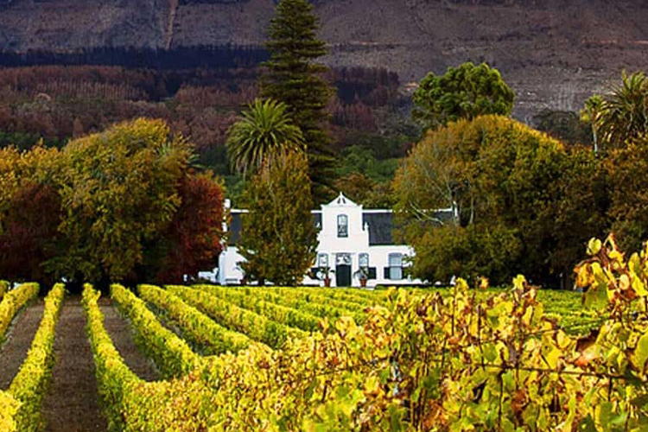

Day 12 Tuesday, March 14.

Franschhoek – D’Aria Wine Estate, Durbanville, Cape Town 85 KM

Breakfast at Mont d'Or

Stands up at 8 am.

A beautiful short ride back to Cape Town, where we will hand our bikes and truck back to the rental company.

We will taxi from Cape Town to the D'Aria wine estate.

Today you can spend a very relaxing last day on the D'Aria wine estate in the Durbanville Hills, which is part of the Durbanville Wine Route.

It will be a perfect day to do your last wine and Gin tasting on the wine estate.

The evening dinner will be a BIG South African Braai (BBQ) with my South African family.

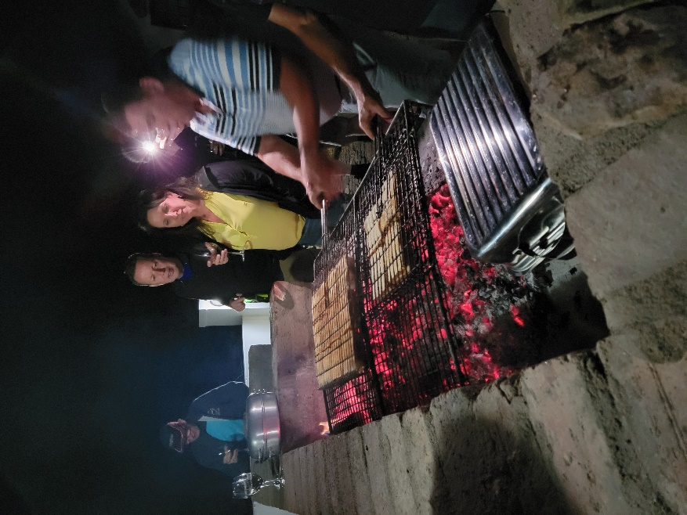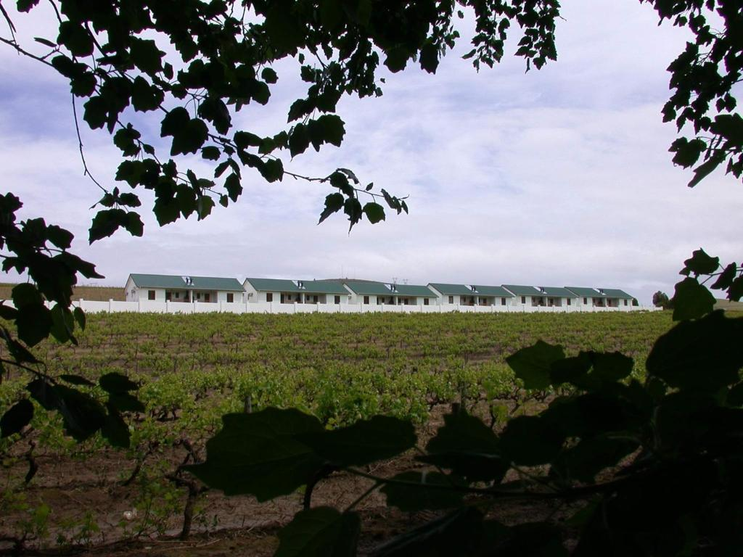

Day 13 Wednesday, March 15.

- Today we will be leaving for the USA.
- The office on the estate can arrange for a taxi to take you to the airport.
- Please make sure that your flight leaves in the afternoon/evening.

Please note:

- I need copies of your driver's license and Passport, please!
- Although you are not required to have an international driver's license to drive in SA, I suggest getting one (Available from AAA offices). It makes traffic stops easier when you must show your license to authorities; they are not the brightest sparks out there.
- If you have any special needs, please let me know. Or, if you have any health problems, we need to know about them. If you have diabetes or suffer from low blood sugar, please let us know, and please plan to have your snack foods with you on the bike in case there are delays and we can't make the scheduled food stops. This point is critical as things can, and do, change on trips like this.
- Please forward your full names and contact details per email to me, phone, and email addresses.

Tour price:

$4,800 - BMW F750GS/F850GS
$5,200 – BMWR1250GS
$3,000 – Pillion Rider
$3,900 – Truck Driver
$3,900 – Truck Driver Assistant

Included in the tour package:

- Motorcycle Rental and Insurance.
- Gas, tolls, and any entry fees to parks, museums, etc., are not included.
- The insurance access amount is payable with a credit card only and is not included in the tour price. The rental company will block this on your card and only use it if you damage your motorcycle.
- A support vehicle to carry our luggage and refreshments.
- All accommodation (Day 1 to Day 12) I had inquiries about additional days, no problem, but for your account. A few of us will be going a few days earlier to enjoy Cape Town (my hometown).

Meals included:

Day 4 – Breakfast only - Spier Wine Farm
Day 5 – Breakfast only - Aan De Oewer
Day 5 – Breakfast only - Knysna Elephant Park
Day 6 – Breakfast only - Knysna Elephant Park
Day 7 – Breakfast and dinner - Swartberg Private Game Lodge
Day 8 – Breakfast and dinner - Swartberg Private Game Lodge
Day 9 – Breakfast only - Swartberg Private Game Lodge
Day 10 – Breakfast only - Mont d'Or in Franschhoek
Day 11 - Breakfast only- Mont d'Or in Franschhoek
Day 12 – Dinner - D'Aria wine estate

Please note that NO ALCOHOLIC drinks are included in any fees paid by members of this tour group. All alcoholic beverages will be for your account and cannot be added to your room bill (Where applicable).

Payments:

- I will need a 50% deposit to secure our bikes and accommodations by Monday, August 22, 2022 (or earlier).
- March is a popular tourist time; we need to get our bookings in ASAP.
- Payments 1: Zelle to (veloce@nc.rr.com) or 2: Check.
- I do not accept PayPal payments anymore due to their massive fee increase.
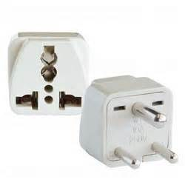
- The final payment is due no later than December 31, 2022.
General points:

- Make sure that your devices are dual/multi-voltage. SA = 220V
- Get some SA currency (Rands) when you arrive in SA. ATMs are in the airport; I usually draw SA cash from them. There are also currency exchange kiosks at the airport in SA if you prefer converting your US Dollars into SA Rands.
- The exchange rate was about R16.50 for $1 US this morning.
- You will need Rands for tips, tolls, gas in some places, etc.
- Gas stations are all "full service," and it is custom to tip your petrol/gas attendant that helps you to fill up. Do not touch a gas pump.
- There are 11 official languages in SA, but most can understand English. Just talk a bit slower for them to understand you. Please call me if you have a problem communicating so I can translate.
- Food quality in SA is outstanding, and you guys should have no problems with tummy bugs.
- Weather & Road Conditions: I strive to schedule my tours at the time of the year when the weather in the touring area is usually pleasant for motorcycling. We may pass through areas where weather conditions can change quickly and significantly. I am not responsible for unpleasant or unsuitable weather or road conditions.
- Please make sure that you have good rain gear and an extra pair of gloves. It isn't easy to dry leather gloves overnight, and you DO NOT want to ride with wet gloves!
- Riding under the influence of alcohol or drugs is strictly prohibited; this speaks for itself!!
- You will adhere to the speed limits at all times. We had several speeding tickets in the past (the truck too). You do not want to get into a traffic court in SA. We will discuss this point in more detail at our first meeting.

We are going to have an absolute blast in SA.

PLEASE CONTACT ME WITH ANY QUESTIONS
johannkeyser@nc.rr.com
TEXT – 919-924-9891

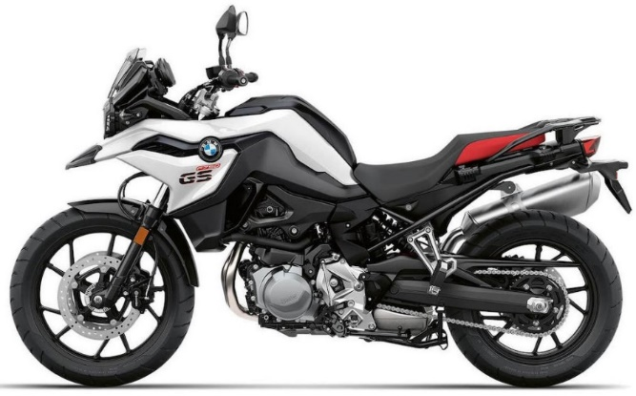BMW F750GS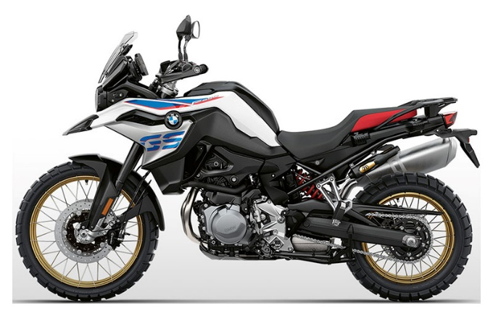BMW F850GS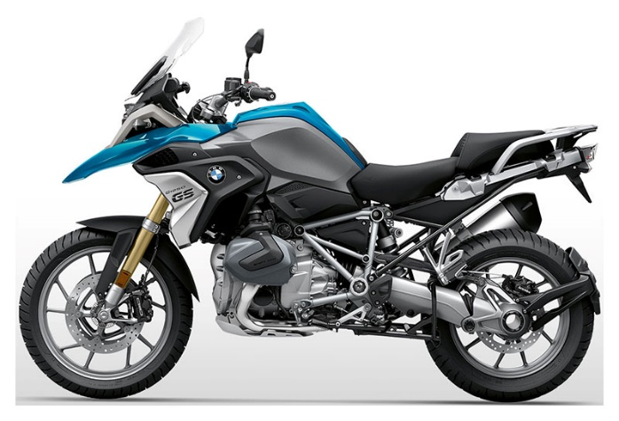BMW R1250GS

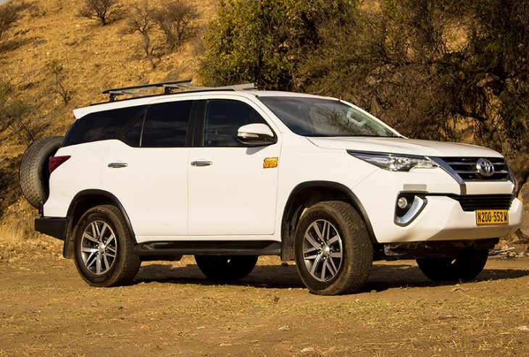TOYOTA FORTUNER (Backup truck)

Video link for the 2022 Tour:
https://www.youtube.com/watch?v=n_SYSk8_ezw&t=18s

Picture link for the 2022 Tour:
https://www.youtube.com/watch?v=5Ut6wlZdVzY

